Time gpt

Introduction:

Gallium, indium, and cobalt are pivotal in advancing clean energy technologies due to their unique properties and applications:

**Gallium**: Utilized in gallium-arsenide (GaAs) and copper-indium-gallium-diselenide (CIGS) thin-film solar cells, gallium enhances the efficiency of photovoltaic systems. Its role in semiconductors is crucial for high-efficiency solar panels. <https://www.usgs.gov/media/images/critical-mineral-commodities-renewable-energy>

**Indium**: Indium is a key component in CIGS thin-film solar cells, contributing to their efficiency and performance. Additionally, indium-tin-oxide (ITO) is used in transparent conductive coatings for touch screens and photovoltaic cells.

<https://www.usgs.gov/media/images/critical-mineral-commodities-renewable-energy>

**Cobalt**: Cobalt is essential in lithium-ion batteries, serving as a component in cathode materials. Its inclusion improves energy density and battery life, making it vital for electric vehicles (EVs) and energy storage systems.

<https://www.usgs.gov/media/images/critical-mineral-commodities-renewable-energy>

**Relationship Between Exogenous Variables and Demand for These Elements**:

* **Price per Unit of Each Element**: The cost of gallium, indium, and cobalt directly influences their demand. Higher prices can lead to increased production costs for clean energy technologies, potentially reducing demand. Conversely, lower prices may encourage adoption and boost demand.
* **Electric Vehicle (EV) Market Growth**: The expansion of the EV market significantly impacts cobalt demand, as lithium-ion batteries in EVs rely on cobalt-containing cathodes. A surge in EV production escalates the need for cobalt.

<https://ourworldindata.org/countries-critical-minerals-needed-energy-transition>

**Lithium-Ion Battery Price**: Decreasing lithium-ion battery prices can stimulate demand for EVs and energy storage solutions, thereby increasing the demand for cobalt. Affordable batteries make clean energy technologies more accessible, driving up the need for critical materials.

TimeGPT is a foundational model for time series forecasting, leveraging transformer-based architectures to predict future values across various domains without additional training. It processes historical data and exogenous variables to generate accurate forecasts, accommodating diverse input sizes and forecasting horizons. TimeGPT's adaptability and efficiency make it a valuable tool for anticipating market dynamics in critical materials

Despite their importance, the supply chains for these materials face significant risks:

* **Supply Concentration**: A substantial portion of gallium and indium production is concentrated in a few countries, notably China, which poses risks of supply disruptions due to geopolitical tensions or export restrictions.{ <https://www.csis.org/analysis/de-risking-gallium-supply-chains-national-security-case-eroding-chinas-critical-mineral> }
* **Market Volatility**: The prices of these materials are subject to fluctuations due to varying demand and speculative trading, leading to uncertainties in the cost structures of clean energy technologies.{ <https://link.springer.com/article/10.1007/s40243-019-0146-z> }

**Supply Chain Complexity:** The intricate and opaque nature of critical material supply chains further complicates data collection and analysis, making it difficult to track material flows and demand accurately { https://www.darpa.mil/news-events/2023-10-24a }

**Supply Chain Management:** Insights into future demand can guide strategic planning, inventory management, and risk mitigation efforts.{ <https://www.darpa.mil/news-events/2023-10-24a> }

Supply Chain Risks

Geopolitical Concentration: Over 40% of global reserves for critical metals like cobalt are concentrated in specific countries, such as the Democratic Republic of Congo, creating vulnerability to geopolitical tensions(Müller et al., 2024).{ <https://www.doi.org/10.1016/j.geogeo.2024.100310> }

Market Shocks: The International Energy Agency (IEA) highlights that critical minerals are susceptible to market disruptions, which can affect their availability during the energy transition { https://www.doi.org/10.22617/brf240251-2 }  
  
Transitioning to a low-carbon economy could require a five-to-sevenfold increase in critical material flows by 2050, with gallium and indium seeing particularly high demand {https://www.doi.org/10.1111/jiec.13479}

Rising demand for critical metals due to population growth and green energy transition.

Limited supply and recycling challenges pose significant risks.

The demand for critical materials such as Gallium, Indium, and Cobalt is significantly influenced by exogenous variables, particularly the adoption of electric vehicles (EVs), pricing dynamics, and the costs associated with lithium-ion batteries. These factors interplay to shape the market landscape for these essential materials in the clean energy transition.

Impact of EV Adoption

The surge in EV adoption directly increases the demand for critical metals, particularly Cobalt and Lithium, which are integral to battery production(Shojaeddini et al., 2024). { <https://www.doi.org/10.1016/j.resconrec.2024.107664> }

As EV sales rise, the demand for lithium-ion batteries escalates, further driving the need for these critical materials(Park & Melendez, 2024). { <https://www.doi.org/10.22617/brf240251-2> }

Methodology :

https://www.datacamp.com/tutorial/time-series-forecasting-with-time-gpt

[TimeGPT-1](https://arxiv.org/abs/2310.03589) is a Transformer-based time series model with [self-attention mechanisms](https://www.datacamp.com/blog/attention-mechanism-in-llms-intuition) that you can access using the Nixtla API. It is the first foundational model for time series datasets that is fairly accurate on unseen data. All you have to do is fine-tune it on your dataset, and within a few seconds, it will provide state-of-the-art performance.

The TimeGPT architecture consists of an encoder-decoder structure with multiple layers, each equipped with residual connections and layer normalization. The output layer is linear and maps the decoder's output to the forecasting window's dimension.

It was trained on the largest collection of publicly available time series data, meaning it can forecast unseen datasets without requiring retraining. To produce a forecast, TimeGPT takes a window of previous values and adds a local positional encoder to enhance the input.

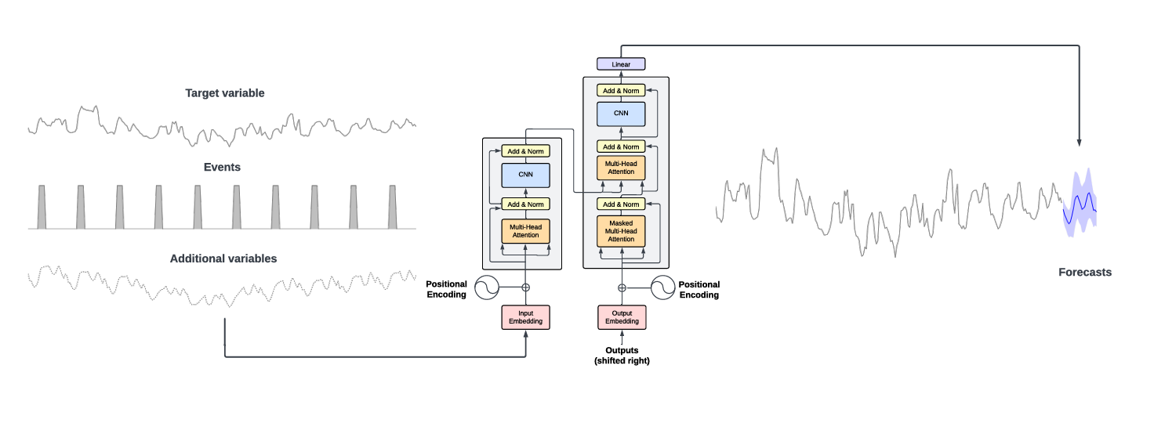

The TimeGPT model outperforms established statistical, machine learning, and deep learning methods, showcasing superior zero-shot inference performance, efficiency, and simplicity. As demonstrated in the benchmark below, TimeGPT excels across various machine learning metrics even without any feature engineering.{ <https://arxiv.org/pdf/2310.03589>}

Time gpt paper:   
TimeGPT, the first foundation model for time series, capable of generating accurate predictions for diverse datasets not seen during training. We evaluate our pre-trained model against established statistical, machine learning, and deep learning methods, demonstrating that TimeGPT zero-shot inference excels in performance, efficiency, and simplicity

However, with the advent of deep learning, a paradigm shift in time series analysis has occurred. Deep learning methods have become popular in academia and for large-scale industrial forecasting applications [Benidis et al., 2022]{ [Deep Learning for Time Series Forecasting: Tutorial and Literature Survey | ACM Computing Surveys](https://dl.acm.org/doi/10.1145/3533382)}. Given their global approach, deep learning methods offer significant advantages over statistical local methods in terms of scalability, flexibility, and potential accuracy.

consequently, deep learning-based time series models aim to simplify the forecasting pipeline and enhance scalability,

. Conversely, some industry leaders report that the deep learning approach has enhanced their results and simplified their analysis pipelines [Kunz et al., 2023] {[[2305.14406] Deep Learning based Forecasting: a case study from the online fashion industry](https://arxiv.org/abs/2305.14406)}.

Literature review:   
Deep Learning forecasting models have become a prominent area of research, driven by their success in recent famous competitions, including {[M5 accuracy competition: Results, findings, and conclusions - ScienceDirect](https://www.sciencedirect.com/science/article/pii/S0169207021001874)}

Transformer-based models [Vaswani et al., 2017] are gaining popularity in recent years, as they are demonstrating remarkable performance in large-scale settings {[[2305.14406] Deep Learning based Forecasting: a case study from the online fashion industry](https://arxiv.org/abs/2305.14406)}.

TimeGPT is a Transformer-based time series model with self-attention mechanisms based on [Vaswani et al., 2017] {Ashish Vaswani, Noam Shazeer, Niki Parmar, Jakob Uszkoreit, Llion Jones, Aidan N Gomez, Łukasz Kaiser, and Illia Polosukhin. Attention is all you need. Advances in neural information processing systems, 30, 2017}. TimeGPT takes a window of historical values to produce the forecast, adding local positional encoding to enrich the input. The architecture consists of an encoder-decoder structure with multiple layers, each with residual connections and layer normalization. Finally, a linear layer maps the decoder’s output to the forecasting window dimension. The general intuition is that attentionbased mechanisms are able to capture the diversity of past events and correctly extrapolate potential future distributions.

TimeGPT was trained on, to our knowledge, the largest collection of publicly available time series, collectively encompassing over 100 billion data points. This training set incorporates time series from a broad array of domains, including finance, economics, demographics, healthcare, weather, IoT sensor data, energy, web traffic, sales, transport, and banking

Relative Mean Absolute Error (rMAE) for TimeGPT and various groups of models for montly frequency. Each bean in the plot represents the rMAE distribution for a group, with the central line showing the mean. TimeGPT leads in performance, followed by deep learning methods, statistical, machine learning, and baseline models. Results are analogous for other frequencies.